**FUNDAMENTALS OF DATABASES – WEEK 3 – ACTIVITY 1**

Supply/perform what is asking in the following statements. Attach or put a screenshot for each number to support your answers.

1. Search a website or install a free software (for those who have laptop) which can be used as example of different types of interfaces for database or data management in the software/system.
2. Capture or make a screenshot for each types of interface given below and briefly explain its importance or benefits to the users.
   1. Menu-Based Interface – for us to easily recognize and distinguish all the menu’s we are able to use in order to go in the particular parts of the application/website or software.

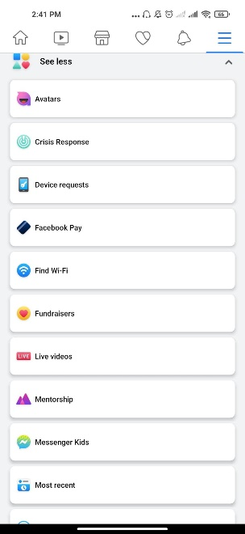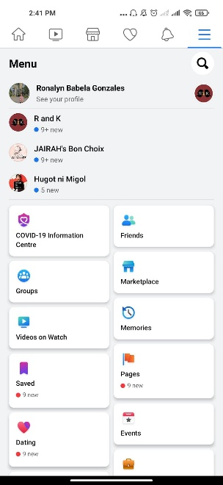

* 1. Forms-Based Interface – this is where all the information is gathered and listed.

 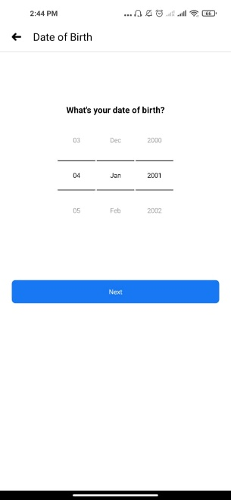 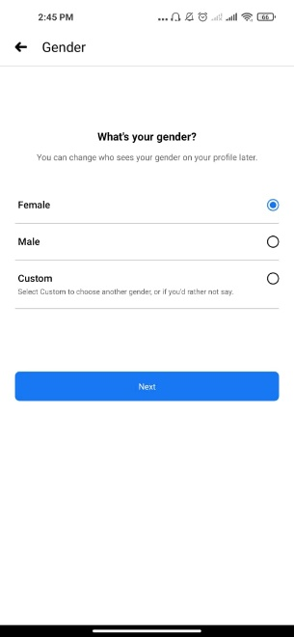

* 1. Graphical User Interface – this is where all movements or interactions are calculated or being monitored.

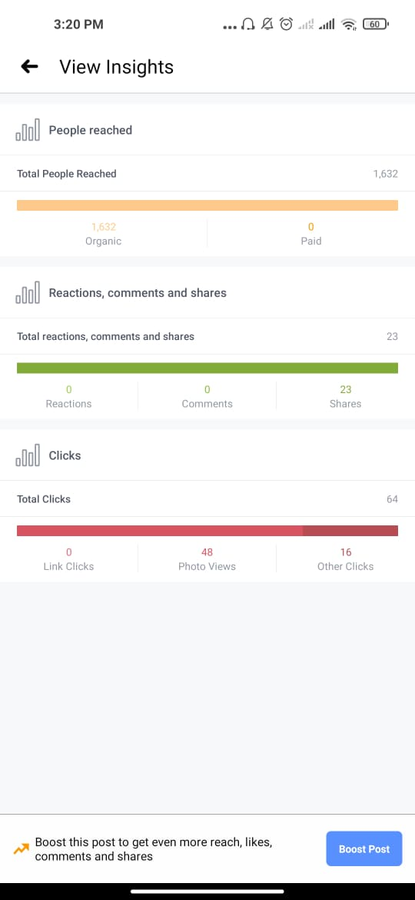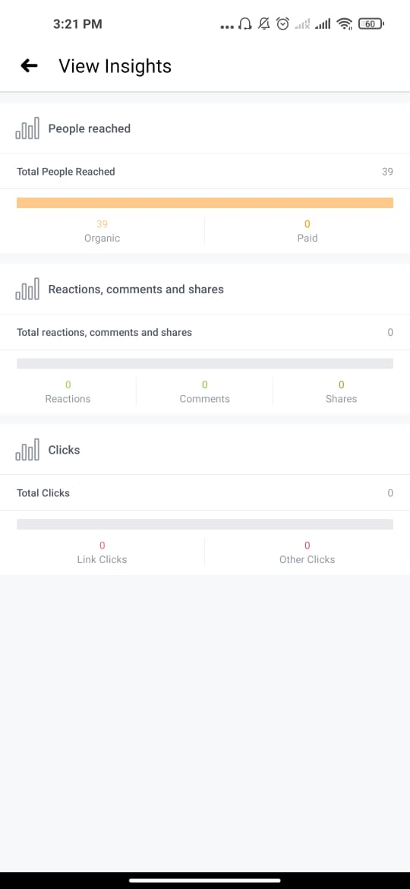

* 1. Natural language Interface – in this part, through the use of this medium it can help a lot by just click.

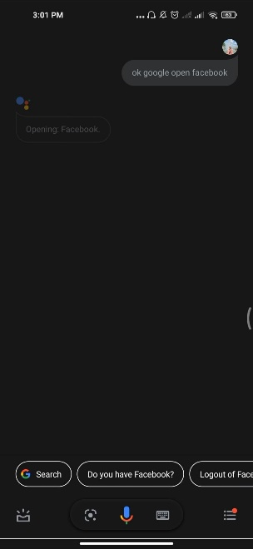

* 1. Speech Input and Output – in this part where you can send your thoughts through a special interface where it can be great help in terms of accessability.



* 1. Interfaces for DBA – this is where all the data are gathered.

